South Stoke Primary School
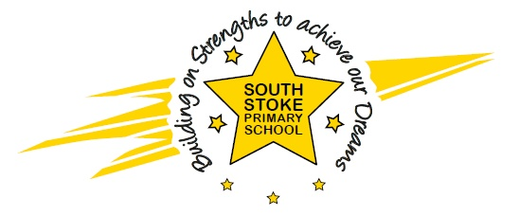
The Street
South Stoke
Nr Reading
RG8 0JS
Telephone / Fax: 01491 872948
Email – office.2507@south-stoke.oxon.sch.uk
www.southstokeschool.org

Headteacher – Miss Amanda Rogers
September 2022

TERM DATES 2022/23

SEPTEMBER 2022
2nd/5th&6th INSET DAYS
7TH TERM STARTS
21ST END OF TERM (3.15PM FINISH)

24TH-28TH HALF TERM BREAK

31ST TERM STARTS
16TH END OF TERM
19TH& 20TH INSET DAYS

21ST-3RD JAN CHRISTMAS BREAK
JANUARY 2023
4TH TERM STARTS
10TH END OF TERM

13TH-17TH HALF TERM BREAK

20TH TERM STARTS
31ST END OF TERM (1PM FINISH)

3RD-14TH EASTER BREAK

17TH TERM STARTS
26TH END OF TERM

30TH- 2ND JUNE HALF TERM BREAK

5TH TERM STARTS
21ST END OF TERM

